Task 1
Write a python program that prints all the Fibonacci numbers from 0 to N where N will be given as input by the user.
A Fibonacci number is a number which is the summation of its previous two Fibonacci numbers.
The first two Fibonacci numbers are 0 and 1.
So, the 3rd is 0 + 1 = 1,
the 4th is 1 + 1 = 2,
the 5th is 1 + 2 = 3,
the 6th one is 2 + 3 = 5,
and so on.
i.e. 0, 1, 1, 2, 3, 5, 8, 13, 21.......
===============================================================Sample Input 1:
10
Sample Output 1:
0 1 1 2 3 5 8
Explanation: All Fibonacci numbers up to the number 10 is printed separated by spaces.
===============================================================Sample Input 2:
15
Sample Output 2:
0 1 1 2 3 5 8 13
Explanation: All Fibonacci numbers up to the number 15 is printed separated by spaces.

Task 2
Write a Python program that asks the user for a range (a starting number and an ending number) and then counts how many numbers are prime numbers and how many numbers are perfect numbers between that range. It also prints those numbers in the format shown in the output of the example given below.
===============================================================
Hint (1): We may declare two strings/lists to store the prime and perfect numbers. Inside the loop, we check for prime and perfect numbers and add them to respective string/list besides counting them.
Hint (2): We may need to convert numbers in String to integers for checking and calculations. We may again need to convert numbers to Strings for storing and printing as the outputs shown in the example below.
===============================================================
Example: If the user gives us a range of between 2 and 6, there are 3 prime numbers (2, 3, 5) and 1 perfect number (6) in that range.
Input:
2
6
Output:
Between 2 and 6,
Found 3 prime numbers
Found 1 perfect number
Prime numbers: 2, 3, 5
Perfect number: 6
Task-3
Imagine you are playing a game with your friend which is quite similar to ludo. The player who crosses
throughout the board of 25 boxes wins. Each of you gets to roll the dice and can get from 1-6.
If both players converge on the same box, the player’s avatar coming to this box previously will get eaten and
the player will lose.
There are certain checkboxes in the board where the avatars cannot be eaten. The checkpoints are 10th and
20th.
Until a player’s avatar gets eaten or he/she crosses the 25th box, the dice will be rolled between the players
and the game will continue.
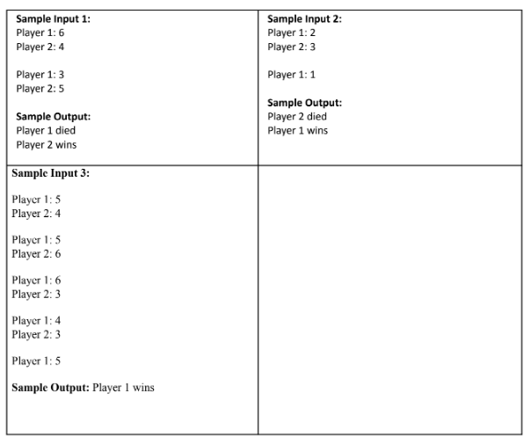
TASK-4
Rhombus, Just draw the image of the above triangle once. And then, the opposite, once.
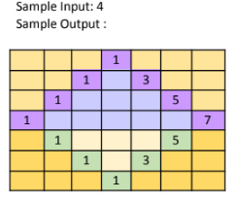

TASK-2
Write a python program that prints alphabet pattern 'Z' of size N using * where N will be
given as input.
Sample Input1: 5
Sample Output1:
